

**1.**

## A Project Report On



**Brainstrom**

Submitted in partial fulfillment of the requirement for the award of the degree

Bachelor of Computer Application (BCA)

Academic Year 2019 – 20

|  |  |
| --- | --- |
| **Rajan Thakkar** | **Jay Buddhbhatti** |
| **91700545005** | **91700527092** |

-

**Internal Guide External Guide**

(Name of Internal Guide) (Name of External Guide)



Rajkot-Morbi Road, At & PO : Gauridad, Rajkot 360 003. Gujarat. India.





**Faculty of Computer Applications (FCA)**



***This is to certify that the project work entitled***

***Brainstrom***

***submitted in partial fulfillment of the requirement for*** ***the award of the degree of***

***Bachelor of Computer Application***

***of the***

***Marwadi University***

***is a result of the bonafide work carried out by***

***Rajan Thakkar - 91700545005***

***Jay Buddhbhatti - 91700527092***

***during the academic year 2019 – 2020***

**Faculty Guide HOD**

**External Viva**

**Name of the Examiners Signature with Date**





**Faculty of Computer Applications (FCA)**



***This is to certify that the project work entitled***

***Brainstrom***

***submitted in partial fulfillment of the requirement for the award of the degree of***

***Bachelor of Computer Application***

***of the***

***Marwadi University***

***is a result of the bonafide work carried out by***

***Rajan Thakkar - 91700545005***

***during the academic year 2019 – 2020***

**Faculty Guide HOD**

**External Viva**

**Name of the Examiners Signature with Date**





**Faculty of Computer Applications (FCA)**



***This is to certify that the project work entitled***

***Brainstrom***

***submitted in partial fulfillment of the requirement for the award of the degree of***

***Bachelor of Computer Application***

***of the***

***Marwadi University***

***is a result of the bonafide work carried out by***

***Jay Buddhbhatti - 91700527092***

***during the academic year 2019 – 2020***

**Faculty Guide HOD**

**External Viva**

**Name of the Examiners Signature with Date**

# DECLARATION



We hereby declare that this project work entitled **Brainstrom** is a record done by me.

We also declare that the matter embodied in this project is genuine work done by me and has not been submitted whether to this University or to any other University / Institute for the fulfillment of the requirement of any course of study.

Place :

Date :

**Rajan Thakkar - 91700545005 Signature :**

**Jay Buddhbhatti - 91700527092 Signature :**

# ACKNOWLEDGEMENT



It is indeed a great pleasure to express my thanks and gratitude to all those who helped me. No serious and lasting achievement or success one can ever achieve without the help of friendly guidance and co-operation of so many people involved in the work.

We are very thankful to my guide **Prof. Jitesh Solanki,** the person who makes me to follow the right steps during a project work. We express my deep sense of gratitude to for his guidance, suggestions and expertise at every stage. A part from that his valuable and expertise suggestion during documentation of my report indeed help me a lot.

Thanks to my friend and colleague who have been a source of inspiration and motivation that helped to me during my project work.

We would heartily thankful to head and DEAN of our department **Dr. Sunil Bajeja and Dr. R. Sridaran** to give me an opportunity to work over this report and for their end-less and great support. And to all other people who directly or indirectly supported and help me to fulfill my task.

**Rajan Thakkar - 91700545005 Signature :**

**Jay Buddhbhatti - 91700527092 Signature :**

**CONTENTS**



|  |  |  |
| --- | --- | --- |
| **Chapters** | **Particulars** | **Page No.** |
| **1** | **SYNOPSIS** | 1 |
| **2** | **PREAMBLE** | 2  3  4  5  6 |
| 2.1 | General Introduction |
| 2.2 | Statement of Problem |
| 2.3 | Objective of the Study |
| 2.4 | Scope of the Study |
| 2.5 | Feasibility Study |
| **3** | **REVIEW OF LITERATURE** | 7  9  9 |
| 3.1 | What is PHP ? |
| 3.2 | About mySQL |
| 3.3 | Kahoot |
| **4** | **TECHNICAL DESCRIPTION** | 10  10 |
| 4.1 | Hardware Requirement |
| 4.2 | Software Requirement |
| **5** | **SYSTEM DESIGN AND DEVELOPMENT** | 11  12  13  14  15  18  20  21 |
| 5.1 | Class Diagram |
| 5.2 | Use Case Diagram |
| 5.3 | Sequence Diagram |
| 5.4 | Activity Diagram |
| 5.5 | Data Flow Diagram |
| 5.6 | Table Structure |
| 5.7 | Menu Design |
| 5.8 | Screen Design |
| **6** | **SYSTEM TESTING** | 33  35  36 |
| 6.1 | Testing Methodology |
| 6.2 | Unit Testing |
| 6.3 | Validation Checking |
| **7** | **CONCLUSION** | 38 |
| **8** | **LEARNING DURING PROJECT WORK** | 39 |
| **9** | **BIBLIOGRAPHY** | 40  40 |
| **9.1**  **9.2** | Online References Offline References |

**FIGURE INDEX**



|  |  |  |  |
| --- | --- | --- | --- |
| **Sr. No.** | **Figure No.** | **Particulars** | **Page No.** |
| 1 | 5.1.1 | Class Diagram | 11 |
| 2 | 5.2.1 | Use Case Diagram | 12 |
| 3 | 5.3.1 | Sequence Diagram (User) | 13 |
| 4 | 5.3.2 | Sequence Diagram (Instructor) | 13 |
| 5 | 5.4.1 | Activity Diagram | 14 |
| 6 | 5.5.1 | Data Flow Diagram Level-0 | 15 |
| 7 | 5.5.2 | Data Flow Diagram Level-1 (Admin) | 15 |
| 8 | 5.5.3 | Data Flow Diagram Level-1 (Instructor) | 16 |
| 9 | 5.5.4 | Data Flow Diagram Level-1 (Student) | 16 |
| 10 | 5.5.5 | Data Flow Diagram Level-2 (Admin) | 17 |
| 11 | 5.5.6 | Data Flow Diagram Level-2 (Instructor) | 17 |
| 12 | 5.7.1 | Main Menu | 20 |
| 13 | 5.7.2 | Admin Menu | 20 |
| 14 | 5.7.3 | Instructor Menu | 20 |
| 15 | 5.7.4 | Student Login Menu | 20 |
| 16 | 5.8.1 | Main Page | 21 |
| 17 | 5.8.2.1 | Student Signup | 21 |
| 18 | 5.8.2.2 | Student Login Page | 22 |
| 19 | 5.8.2.3 | Student Home Page | 22 |
| 20 | 5.8.2.4 | Student History Page | 23 |
| 21 | 5.8.2.5 | Student Ranking Page | 23 |
| 22 | 5.8.3.1 | Admin Login | 24 |
| 23 | 5.8.3.2 | Admin Home Page | 24 |
| 24 | 5.8.3.3 | Admin Instructor Page | 25 |
| 25 | 5.8.3.4 | Admin User Page | 25 |
| 26 | 5.8.3.5 | Admin Ranking Page | 26 |
| 27 | 5.8.3.6 | Admin Feedback Page | 26 |
| 28 | 5.8.3.7 | Admin Add Quiz Page | 27 |
| 29 | 5.8.3.8 | Admin Remove Quiz Page | 27 |
| 30 | 5.8.4.1 | Instructor Signup Page | 28 |
| 31 | 5.8.4.2 | Instructor Login Page | 28 |
| 32 | 5.8.4.3 | Instructor Home Page | 29 |
| 33 | 5.8.4.4 | Instructor User Page | 29 |
| 34 | 5.8.4.5 | Instructor Ranking Page | 30 |
| 35 | 5.8.4.6 | Instructor Add Quiz Page | 30 |
| 36 | 5.8.4.7 | Instructor Remove Quiz Page | 31 |
| 37 | 5.8.5 | Developers Page | 31 |
| 38 | 5.8.6 | Feedback Page | 32 |
| 39 | 6.1.1 | Black Box Testing Diagram | 33 |
| 40 | 6.1.2 | White Box Testing Diagram | 34 |

**TABLE INDEX**



|  |  |  |  |
| --- | --- | --- | --- |
| **Sr. No.** | **Table No.** | **Particulars** | **Page No.** |
| 1 | 5.6.1 | User Table | 18 |
| 2 | 5.6.2 | Question Table | 18 |
| 3 | 5.6.3 | Answer Table | 18 |
| 4 | 5.6.4 | Rank Table | 19 |
| 5 | 5.6.5 | Quiz Table | 19 |
| 6 | 5.6.6 | Feedback Table | 19 |
| 7 | 5.6.7 | Admin Table | 19 |
| 8 | 6.3.1 | Validation Checking (Test Case-1 Name Filed) | 36 |
| 9 | 6.3.2 | Validation Checking (Test Case-2 College Filed) | 36 |
| 10 | 6.3.3 | Validation Checking (Test Case-3 Email Filed) | 36 |
| 11 | 6.3.4 | Validation Checking (Test Case-4 Mobile Number Filed & Length Check) | 36 |
| 12 | 6.3.5 | Validation Checking (Test Case-5 Password Filed & Length Check) | 37 |

**1. Synopsis**

Online quiz are an important method of evaluating the knowledge of students. This research effort the individuals under consideration were students who would be enrolling in computer courses or Technologies Registrations. A prototype of a web-based quiz system is described from the standpoint of the research effort, end user, and software development. An instructor builds a questions based on different topics.

Users enrolled in the platform may access the electronic details they provided and perform various functions with the on-line educational system in order to participate in the on-line quiz. Users can receive an on-line exam, having multimedia content, for the course, and they can electronically provide answers for the quiz and after Completion of their duration of quiz they are provided the grade or marks secured in their quiz.

**2. Preamble**

**2.1 General Introduction**

On-line quiz providers to focus on creating effective assessment questions and focusing on quiz’s feedback delivery to students. In the paper we present techniques that are pertinent to the elements of assessment process: answers submission, computerized grading, and feedback after submission.

As the modern organizations are automated and computers are working as per the instructions, it becomes essential for the coordination of human beings, commodity and computers in a modern organization.

The administrators, instructor, Students who are attending for online examination can communicate with the system through this projects, thus facilitating effective implementation and monitoring of various activities of Online quiz like conducting Exams as per scheduled basis and delivering result to that particular use or student and the details of students who attempted Online quiz are maintained at administrator.

**2.2 Statement of Problem**

In offline or manual system we cannot maintain records properly. In manual system students have a quiz in the paper and their will be mark a answer in the paper. So, many time students will mistake and also the checking time which is check by instructor take more. So, a manual system is very time consuming and also not interesting like a online quiz. In the online quiz students don’t use paper. So, the time which is take more by instructor for checking it will not happen. It is not a time consuming and also students are interested for the participate.

**2.3 Objective of the Study**

To maintain records properly and enroll more in the quiz. We create this web-based quiz. In this website all students details will store in database and also instructor create a quiz it is also store in the database. We can also view our old records. That’s why online quiz system is very faster, safe and easier than manual system.

**2.4 Scope of the Study**

In future we will also attach cloud system. We can also create and android application for students. So, they can give quiz to anytime and anywhere.

**2.5 Feasibility Study**

**2.5.1 Economic Feasibility :-**

Basically this website is develop in a PHP, JavaScript, jQuery, Bootstrap. We don’t afraid of cost & the benefit is high because this is based on online.

**2.5.2 Technical Feasibility :-**

This website will run in any device. We already have a computer in which we develop our project. So, don’t have to afraid about technical feasibility.

**2.5.3 Operational Feasibility :-**

The drawback of manual system we can create this website. In this website we store data in proper manner, display our quiz, students details, questions, answers, options etc.

**3. REVIEW OF LITERATURE**

**3.1 What is PHP**

* The full form of PHP is “Hypertext Preprocessor”. Its original name was “Personal Home Page”
* Rasmus Lerdorf software engineer, Apache team member is the creator and original driving force behind PHP. The first part of PHP was developed for his personal use in late 1994.By the middle of 1997, PHP was being used on approximately 50,000 sites worldwide.
* PHP is server-side scripting language, which can be embedded in HTML or used as a stand-alone.
* PHP doesn’t do anything about what a page looks and sounds like. In fact, most of what PHP does is invisible to the end user.
* Someone looking at a PHP page will not necessarily be able to tell that it was not written purely in HTML, because usually the result of PHP is HTML.
* PHP is an official module of Apache HTTP Server.
* PHP is fully cross-platform, meaning it runs native on several flavors of Unix, as well as on Windows and now on Mac OS X.

**Advantages of PHP**

* **Cost** : PHP costs you nothing. It is open source software and doesn’t need to purchase it for development.
* **Ease of Use** : PHP is easy to learn, compared to the others. A lot of Ready-made PHP scripts are freely available in market so, you can use them in your project or get some help from them.
* **HTML- Support** : PHP is embedded within HTML; In other words, PHP pages are ordinary HTML pages that escape into PHP mode only when necessary. When a client requests this page, the web server preprocesses it. This means it goes through the.
* page from top to bottom, looking for sections of PHP,which it willtry to resolve**.**
* **Cross-platform compatibility :** MySQL run native on every popular flavor of Unix and windows. A huge percentage PHP and of the world’s HTTP servers run on one of these two classes of operating system.
* **PHP is compatible with the three leading Web servers :** Apache HTTP Server for Unix and Windows, Microsoft Internet Information Server, and Netscape Enterprise Server. It also works with several lesser-known servers, including Alex Blits’ fhttpd, Microsoft’s Personal Web Server, AOL Server and Omnicentrix’s Omni server application server.
* **Stability :** The word stable means two different things in this context:
  + - * The server doesn’t need to be rebooted often
      * The software doesn’t change radically and incompatibly from release to release.To our advantage, both of these apply to both MySQL and PHP.
* **Speed** : PHP is pleasingly zippy in its execution, especially when compiled as and Apache module on the Unix side. Although it takes a slight performance hit by being interpreted rather than compiled, this is far outweighed by the benefits PHP drives from its status as a Web server module.

**3.2 About MySQL**

**MySQL Database Management System**

* MySQL, the most popular Open Source SQL database management system, is developed, distributed, and supported by MySQL AB.
* MySQL AB is a commercial company, founded by the MySQL developers. It is a second generation Open Source Company that unites Open Source values and methodology with a successful business model.
* The MySQL Web site (<http://www.mysql.com/>) provides the latest information about MySQL software and MySQL AB.
* The official way to pronounce “MySQL” is “My Ess Que Ell” (not “my sequel”), but we don't mind if you pronounce it as “my sequel” or in some other localized way.

**MySQL Features :**

* MySQL is a database management system.
* MySQL is a relational database management system.
* MySQL software is Open Source.
* The MySQL Database Server is very fast, reliable, and easy to use.
* MySQL Server works in client/server or embedded systems.

**3.3 We have reference Kahoot**

**Kahoot** is a free game-based platform where students can participate and get a response from the teachers in real time. The Kahoot tool is like an advanced platform for learning and playing games. The platform also lets others create and launch their own games so other players can also play and explore the new games every day. The platform is used by millions of people around the world to discover, play and share a variety of games with others. It’s like a collaborative platform for learning new things on a daily basis.

**4. TECHNICAL DESCRIPTION**

**4.1 Hardware Requirement**

All the devices which have browser inside it. So, it will run website.

**4.2 Software Requirement**

If we hosting our website so there is no need of any software but at now a computer have PHP, browser, xampp so they can easily run our Brainstrom project.

**5. SYSTEM DESIGN AND DEVELOPMENT**

**5.1 Class Diagram**

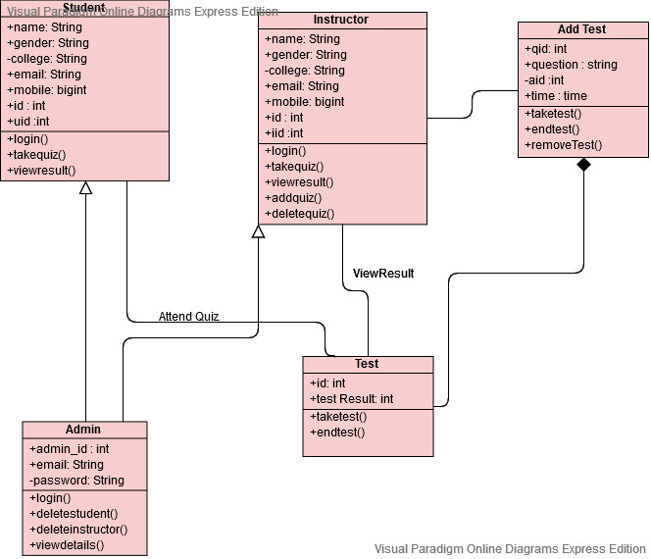

Figure 5.1.1

**5.2 Use Case Diagram**

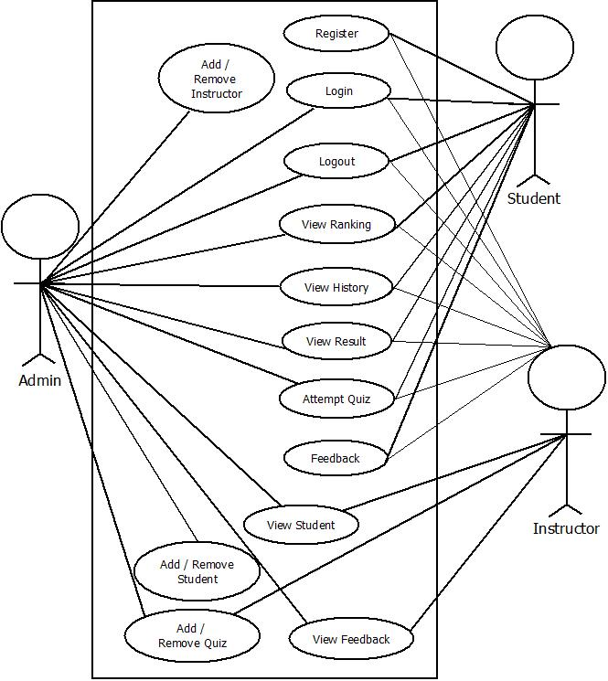

Figure 5.2.1

**5.3 Sequence Diagram**

5.3.1 User :-

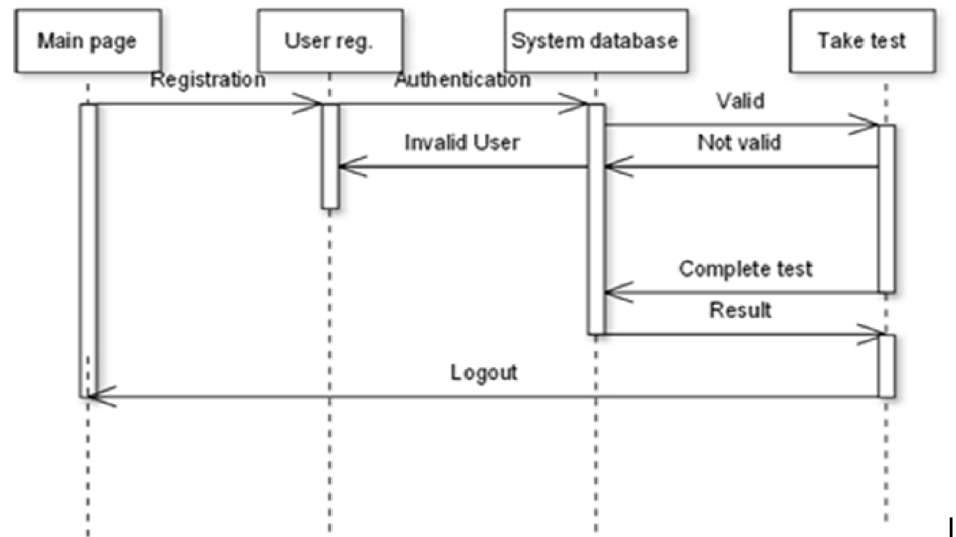

Figure 5.3.1

5.3.2 Instructor :-

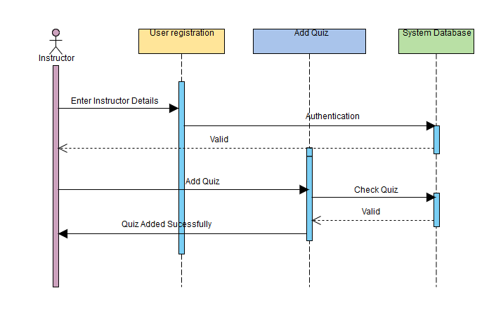

Figure 5.3.2

**5.4 Activity Diagram**

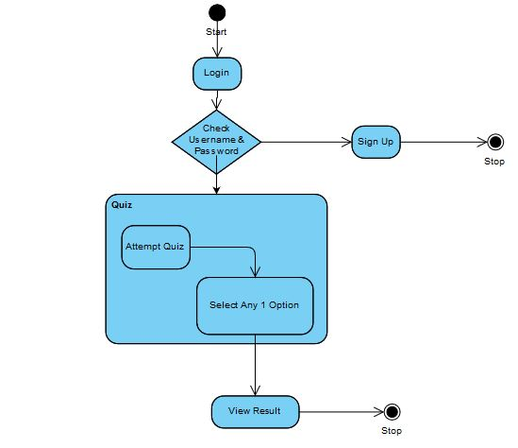

Figure 5.4.1

**5.5 Data Flow Diagram**

5.5.1 DFD 0 :-

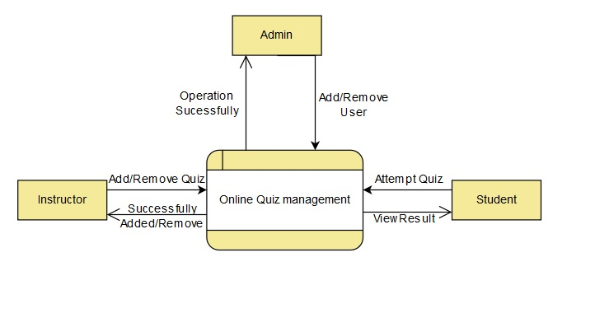

Figure 5.5.1

5.5.2 DFD 1 Admin :-

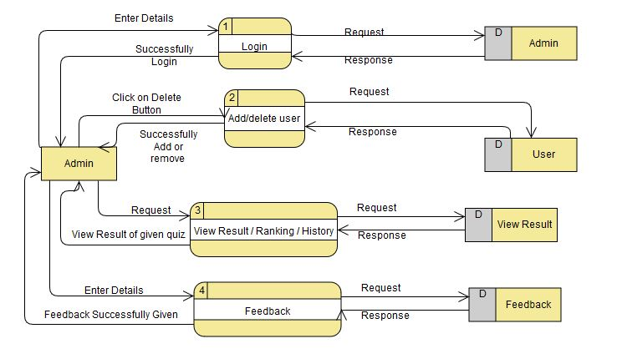

Figure 5.5.2

5.5.3 DFD 1 Instructor :-

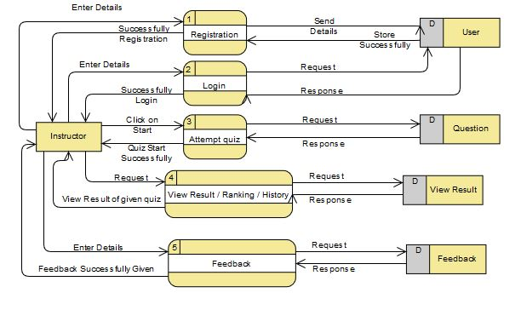

Figure 5.5.3

5.5.4 DFD 1 Student :-

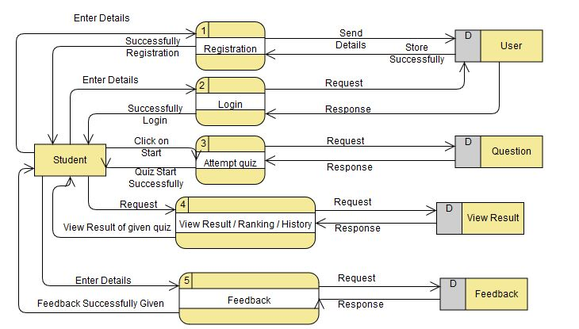

Figure 5.5.4

5.5.5 DFD 2 Admin :-

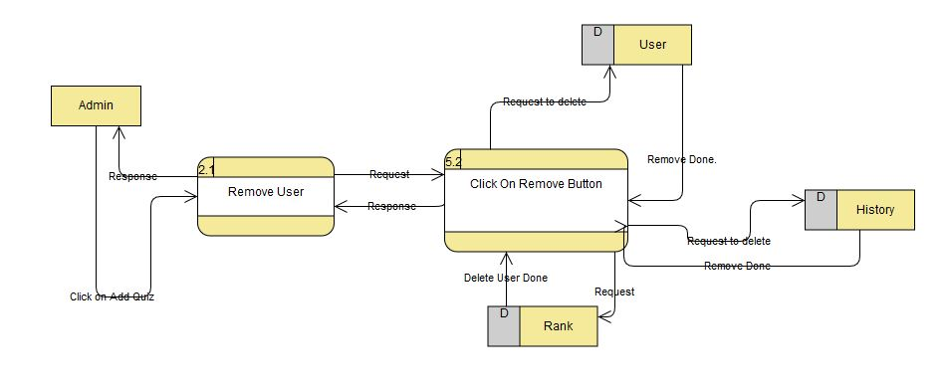

Figure 5.5.5

5.5.6 DFD 2 Instructor :-

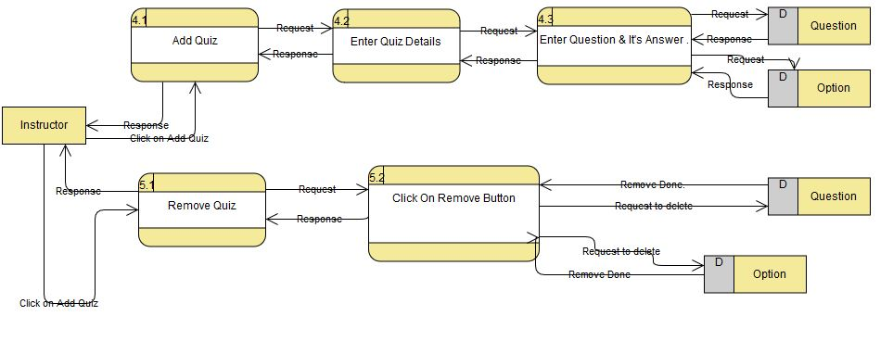

Figure 5.5.6

**5.6 Table Structure**

Database Tables :

5.6.1 User Table

|  |  |  |  |  |  |
| --- | --- | --- | --- | --- | --- |
| **Sr. No.** | **Filed Name** | **Data Type** | **Size** | **Constraints** | **Description** |
| 1 | ID | INT | 10 | PRIMARYKEY | NOTNULL |
| 2 | NAME | VARCHAR | 50 | --- | --- |
| 3 | DOB | DATETIME | --- | --- | DATE OF BIRTH |
| 4 | GENDER | VARCHAR | 10 | --- | --- |
| 5 | COLLEGE | VARCHAR | 50 | --- | --- |
| 6 | UID | VARCHAR | 50 | --- | USER ID |
| 7 | PWD | VARCHAR | 20 | --- | PASSWORD |
| 8 | UTYPE | VARCHAR | 20 | --- | USER TYPE |

Table 5.6.1

5.6.2 Question Table

|  |  |  |  |  |  |
| --- | --- | --- | --- | --- | --- |
| **Sr. No.** | **Filed Name** | **Data Type** | **Size** | **Constraints** | **Description** |
| 1 | ID | INT | 10 | PRIMARYKEY | NOTNULL |
| 2 | QUE | VARCHAR | 500 | --- | QUESTION |
| 3 | AW | VARCHAR | 500 | --- | ANSWER |

Table 5.6.2

5.6.3 Answer Table

|  |  |  |  |  |  |
| --- | --- | --- | --- | --- | --- |
| **Sr. No.** | **Filed Name** | **Data Type** | **Size** | **Constraints** | **Description** |
| 1 | ID | INT | 10 | FOREIGNKEY | NOTNULL |
| 2 | AW | VARCHAR | 500 | --- | ANSWER |

Table 5.6.3

5.6.4 Rank Table

|  |  |  |  |  |  |
| --- | --- | --- | --- | --- | --- |
| **Sr. No.** | **Filed Name** | **Data Type** | **Size** | **Constraints** | **Description** |
| 1 | ID | INT | 10 | --- | --- |
| 2 | MARKS | VARCHAR | 10 | --- | --- |

Table 5.6.4

5.6.5 Quiz Table

|  |  |  |  |  |  |
| --- | --- | --- | --- | --- | --- |
| **Sr. No.** | **Filed Name** | **Data Type** | **Size** | **Constraints** | **Description** |
| 1 | QUIZ NAME | VARCHAR | 30 | --- | --- |
| 2 | QUIZ DATE | DATETIME | --- | --- | --- |

Table 5.6.5

5.6.6 Feedback Table

|  |  |  |  |  |  |
| --- | --- | --- | --- | --- | --- |
| **Sr. No.** | **Filed Name** | **Data Type** | **Size** | **Constraints** | **Description** |
| 1 | ID | TEXT | 10 | --- | --- |
| 2 | NAME | VARCHAR | 50 | --- | --- |
| 3 | EMAIL | VARCHAR | 50 | --- | --- |
| 4 | SUBJECT | VARCHAR | 50 | --- | --- |
| 5 | FEEDBACK | VARCHAR | 500 | --- | --- |
| 6 | DATE | DATE | --- | --- | --- |
| 7 | TIME | VARCHAR | 50 | --- | --- |

Table 5.6.6

5.6.7 Admin Table

|  |  |  |  |  |  |
| --- | --- | --- | --- | --- | --- |
| **Sr. No.** | **Filed Name** | **Data Type** | **Size** | **Constraints** | **Description** |
| 1 | ADMIN_ID | INT | 11 | PRIMARYKEY | AUTO INCREMENT |
| 2 | EMAIL | VARCHAR | 50 | --- | NULL |
| 3 | PASSWORD | VARCHAR | 50 | --- | NULL |

Table 5.6.7

**5.7 Menu Design**

5.7.1 Main Menu



Figure 5.7.1

5.7.2 Admin Menu

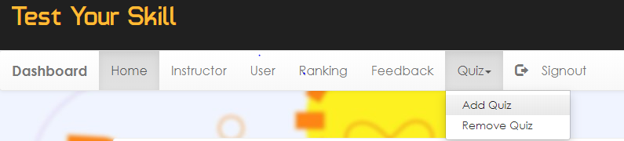

Figure 5.7.2

5.7.3 Instructor Menu

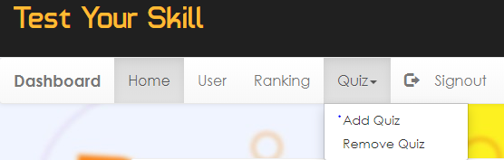

Figure 5.7.3

5.7.4 Student Login Menu



Figure 5.7.4

**5.8 Screen Design**

5.8.1 Main Page

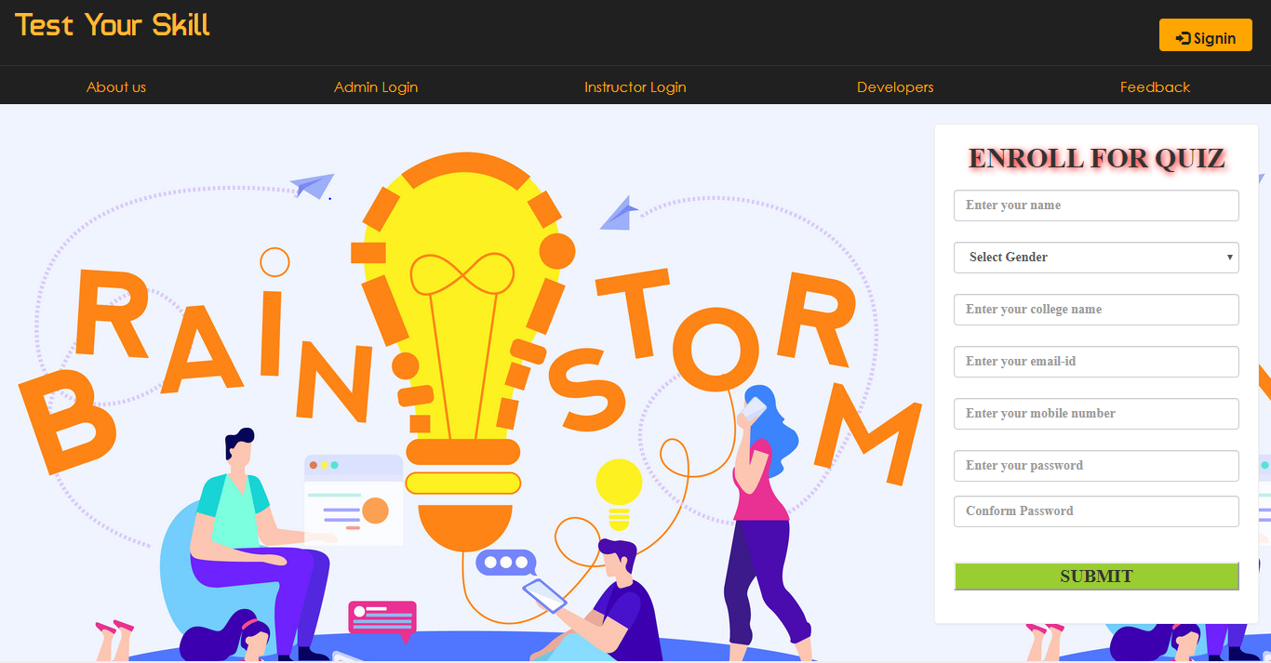

Figure 5.8.1

5.8.2.1 Student Signup

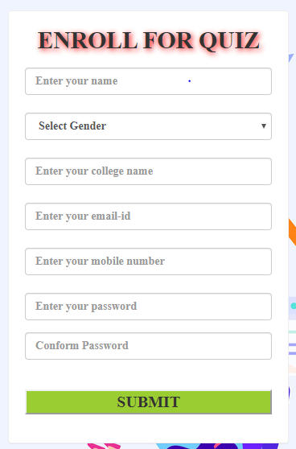

Figure 5.8.2.1

5.8.2.2 Student Login Page

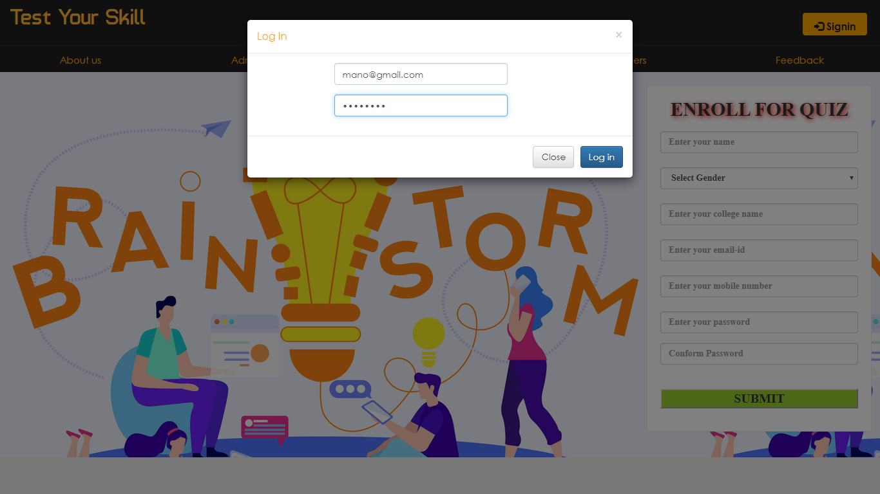

Figure 5.8.2.2

5.8.2.3 Student Home Page

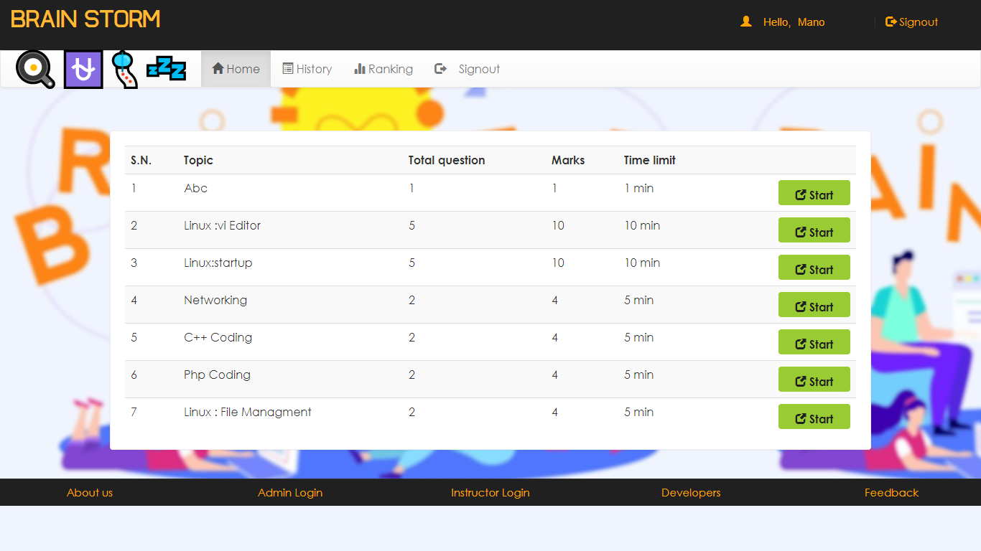

Figure 5.8.2.3

5.8.2.4 Student History Page

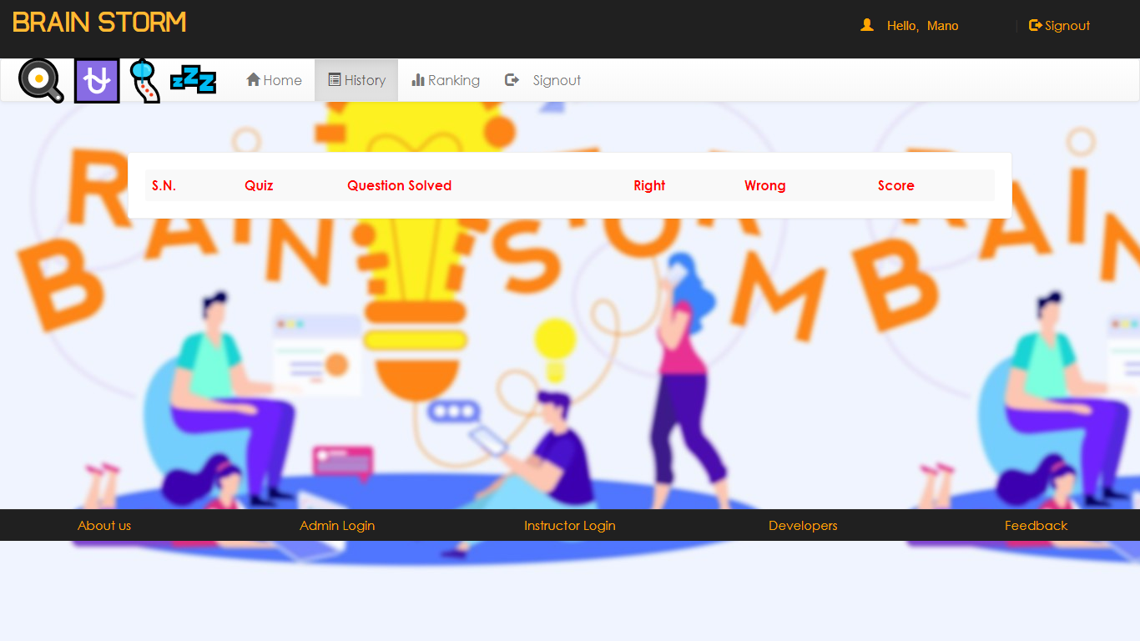

Figure 5.8.2.4

5.8.2.5 Student Ranking Page

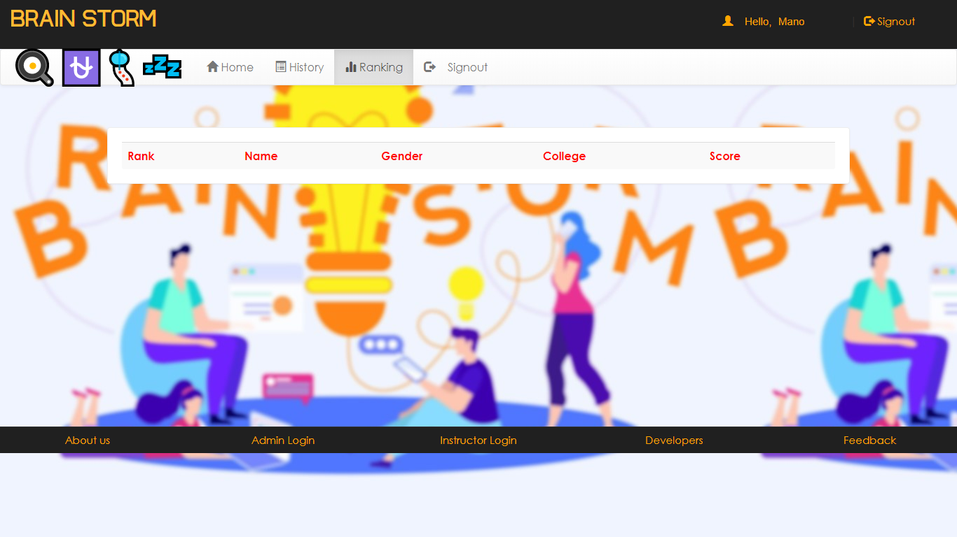

Figure 5.8.2.5

5.8.3.1 Admin Page

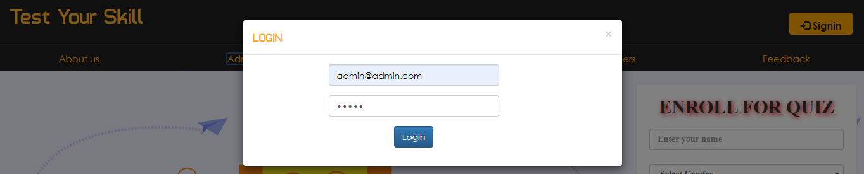

Figure 5.8.3.1

5.8.3.2 Admin Home Page

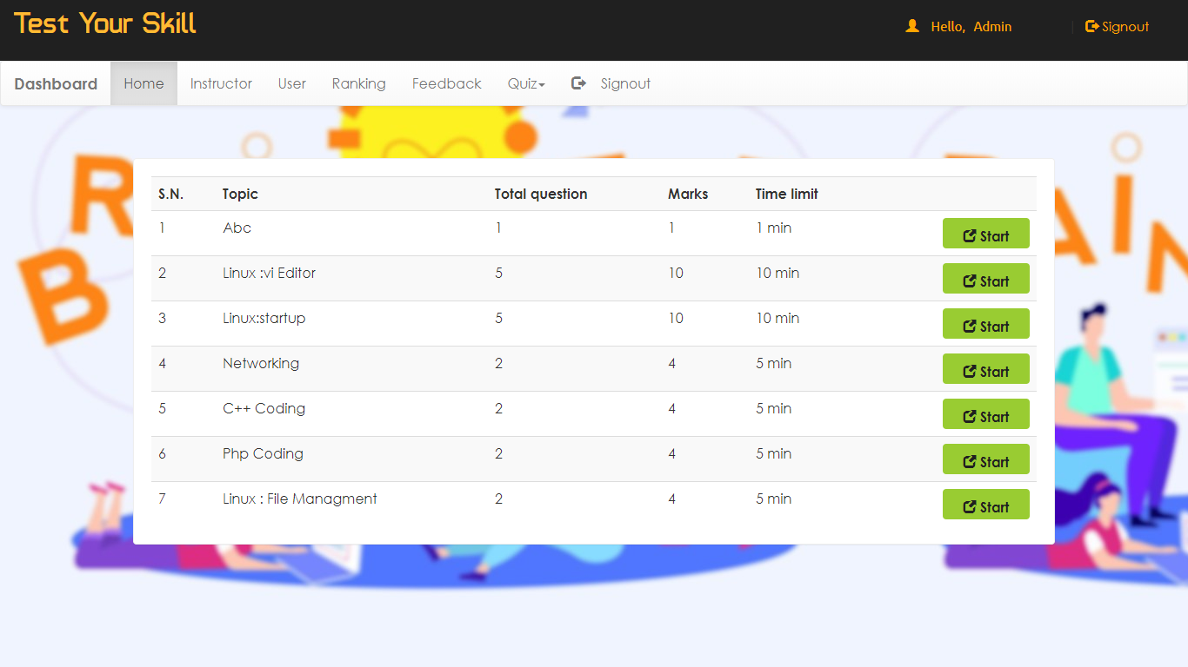

Figure 5.8.3.2

5.8.3.3 Admin Instructor Page

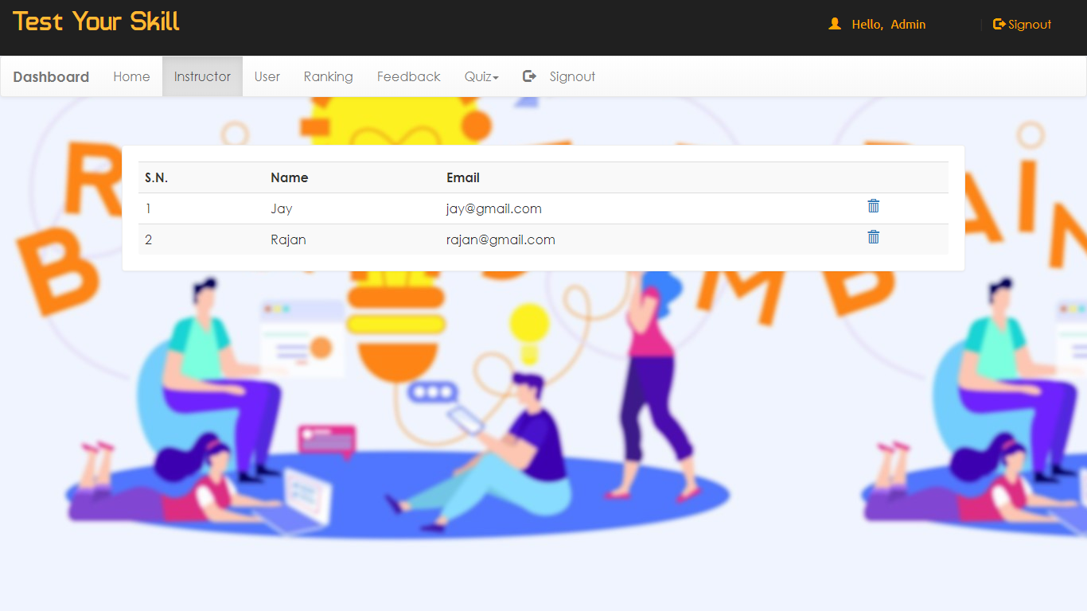

Figure 5.8.3.3

Figure 5.8.3.4

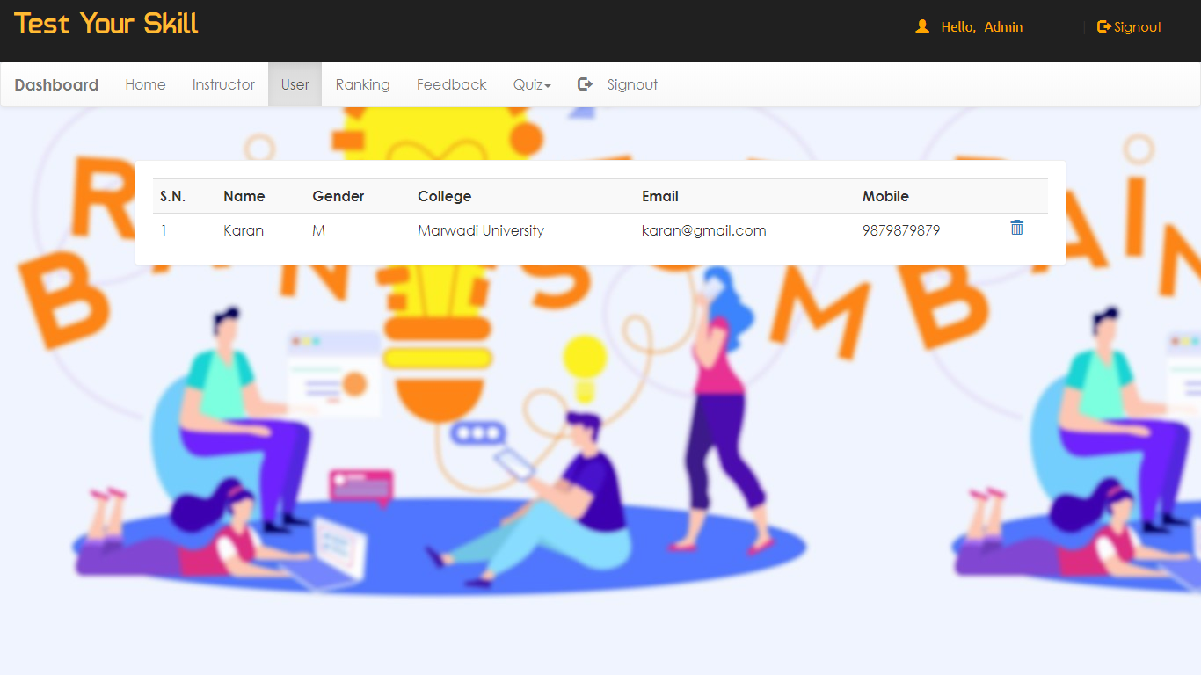

Figure 5.8.3.4

5.8.3.5 Admin Ranking Page

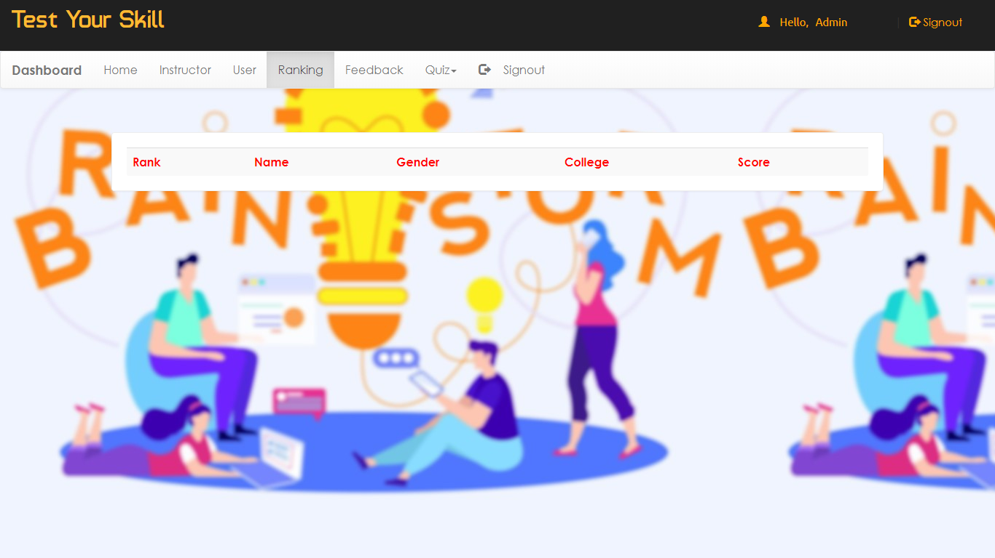

Figure 5.8.3.5

5.8.3.6 Admin Feedback Page

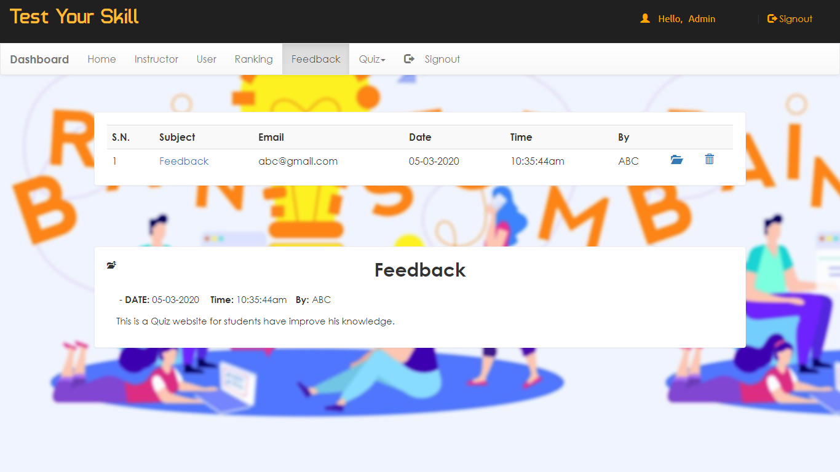

Figure 5.8.3.6

5.8.3.7 Admin Add Quiz Page

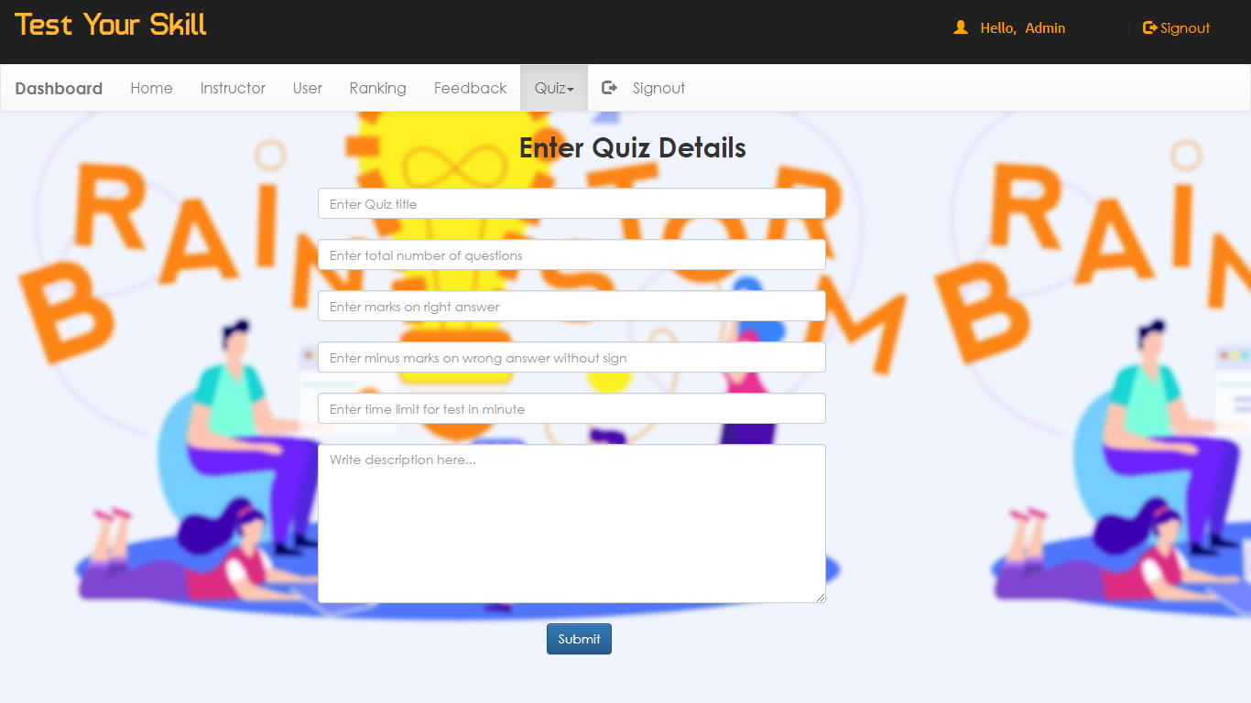

Figure 5.8.3.7

5.8.3.8 Admin Remove Quiz Page

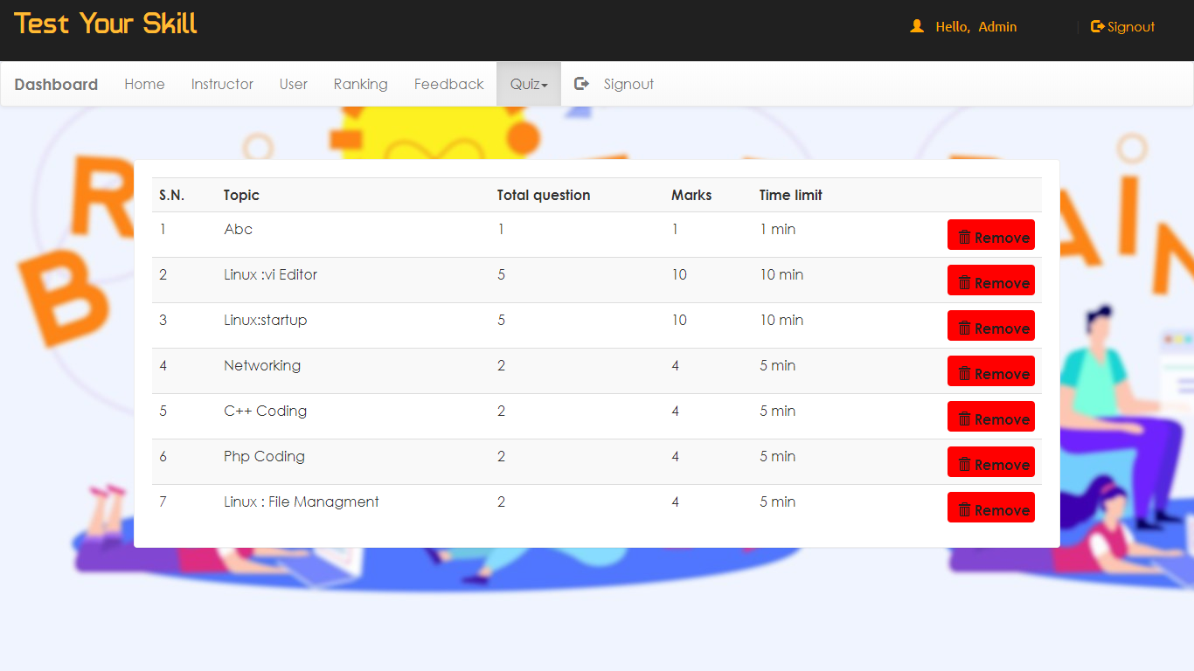

Figure 5.8.3.8

5.8.4.1 Instructor Page

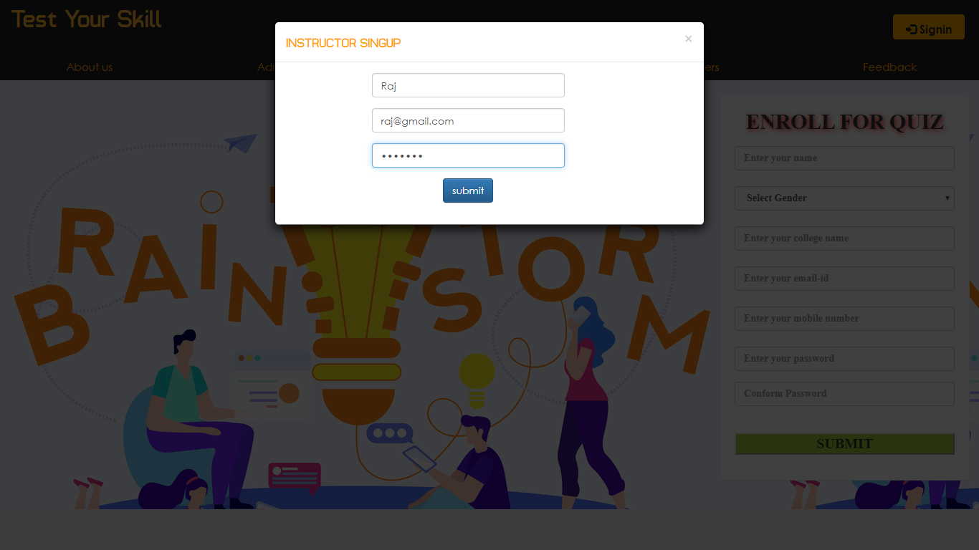

Figure 5.8.4.1

5.8.4.2 Instructor Login Page

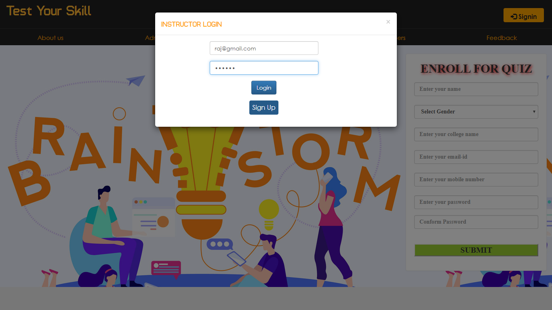

Figure 5.8.4.2

5.8.4.3 Instructor Home Page

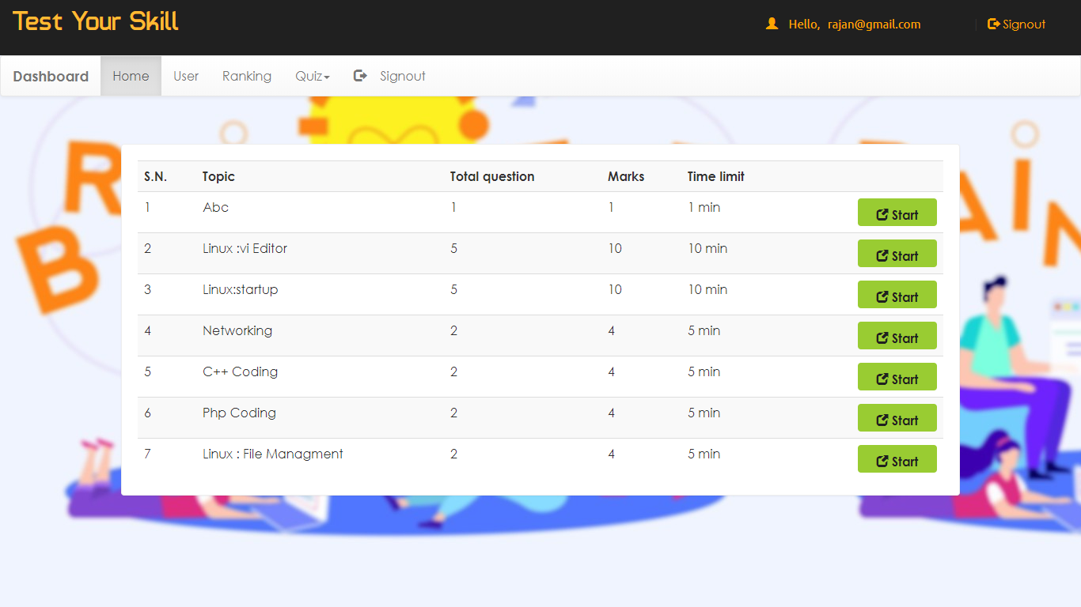

Figure 5.8.4.3

5.8.4.4 Instructor User Page

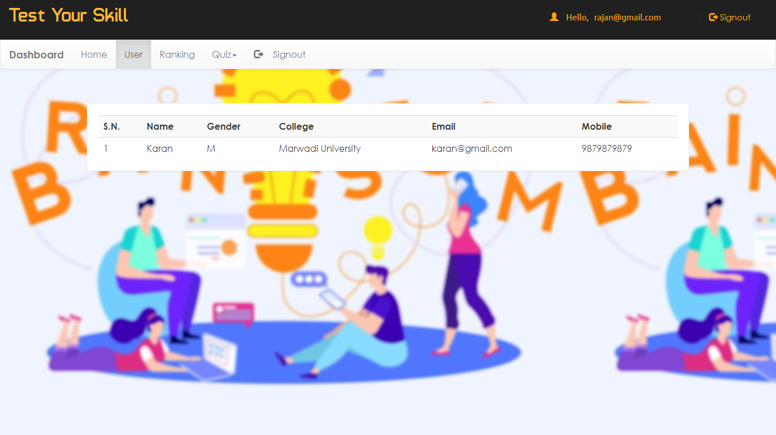

Figure 5.8.4.4

5.8.4.5 Instructor Ranking Page

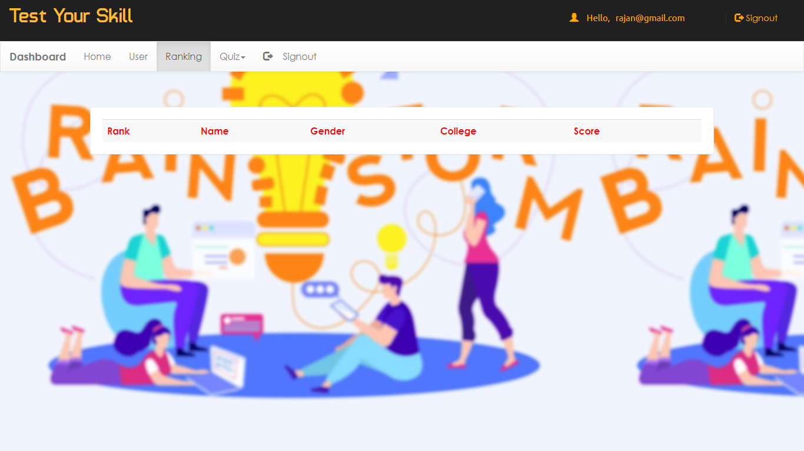

Figure 5.8.4.5

5.8.4.6 Instructor Add Quiz Page

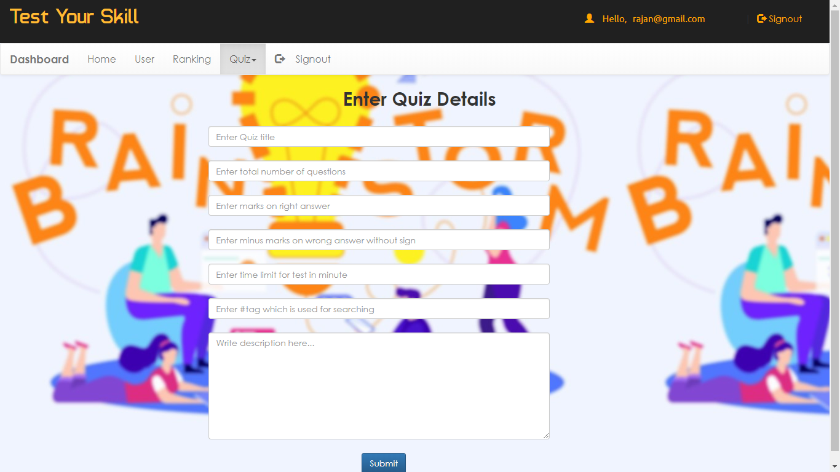

Figure 5.8.4.6

5.8.4.7 Instructor Remove Quiz Page

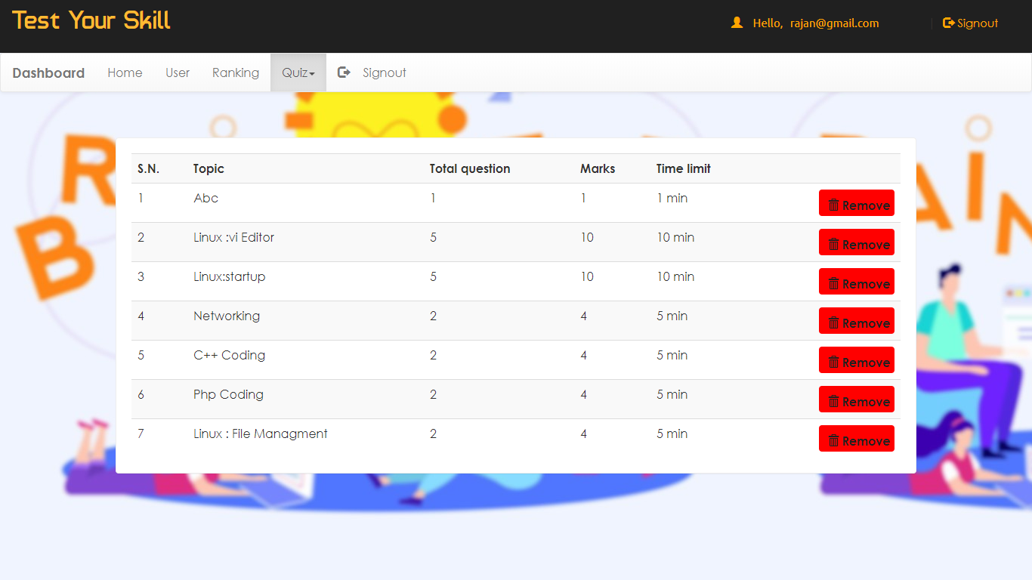

Figure 5.8.4.7

5.8.5 Developers Page

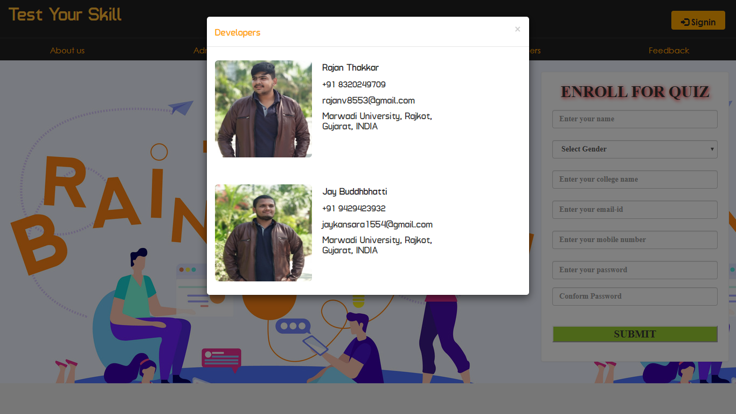

Figure 5.8.5

5.8.6 Feedback Page

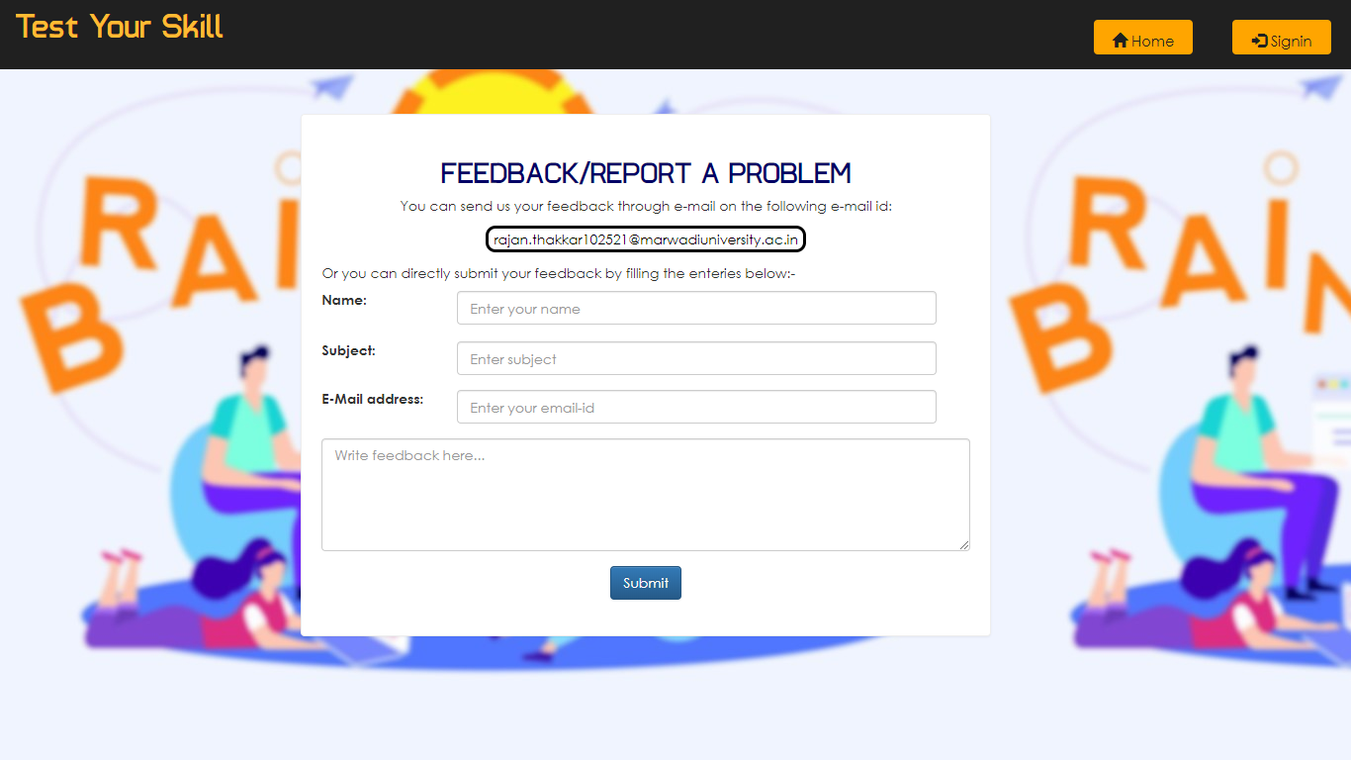

Figure 5.8.6

**6. SYSTEM TESTING**

**6.1 Testing Methodology**

**Black box Testing**

Black box testing is a software testing techniques in which Functionality of the software under test (SUT) is tested without looking at the internal code structure, implementation details and knowledge of internal paths of the software. This type of testing is based entirely on the software requirements and specification.

6.1.1 Black Box Testing Diagram



Figure 6.1.1

The above Black Box can be any software system you want to test. For example : an operating system like Windows, a website like Google ,a database like Oracle or you’re your own custom application. Under Black Box Testing, one can test these applications by just focusing on the inputs and outputs without knowing their internal code implementation.

**White Box Testing**

* White Box Testing is the testing of a software solution’s internal coding and infrastructure. It focuses primarily on strengthening security, the flow of inputs and outputs through the application, and improving design and usability. White box testing is also known as clear, open, structural, and glass box testing.
* White box testing is based on the inner workings of an application and revolves around internal testing. The term "white box" was used because of the see-through box concept.
* The clear box or white box name symbolizes the ability to see through the software's outer shell (or "box") into its inner workings.

6.1.2 Black Box Testing Diagram



Figure 6.1.2

**6.2 Unit Testing**

Unit testing is a level of the software testing process where individual units/components of a software/system are tested. The purpose is to validate that each unit of the software performs as designed. This type of testing is performed by the developers before the setup is handed over to the testing team to formally execute the test cases. Unit testing is performed by the respective developers on the individual units of source code assigned areas. The developers use test data that is separate from the test data of the quality assurance team.

* The goal of unit testing is to isolate each part of the program and show that individual parts are correct in terms of requirements and functionality.
* The limitation of Unit Testing is that this Testing cannot catch each and every bug in an application. It is impossible to evaluate every execution path in every software application. The same is the case with unit testing.

**Function Name :**

We have covered following functions as a unit testing.

(1) validateForm()

(2) secondPassed()

**6.3 Validation Checking**

6.3.1 Test Case - 1 (Name Filed)

|  |  |
| --- | --- |
| Class | Student Registration |
| Description | To check field is not null |
| Input | Name |
| Valid | Successful registration |
| Invalid | Display message Name must be filled out. |

Table 6.3.1

6.3.2 Test Case - 2 (College Filed)

|  |  |
| --- | --- |
| Class | Student Registration |
| Description | To check field is not null |
| Input | College |
| Valid | Successful registration |
| Invalid | Display message College must be filled out. |

Table 6.3.2

6.3.3 Test Case - 3 (Email Filed)

|  |  |
| --- | --- |
| Class | Student Registration |
| Description | To check field is not null |
| Input | Email |
| Valid | Successful registration |
| Invalid | Display message Not a valid e-mail address. |

Table 6.3.3

6.3.4 Test Case - 4 (Mobile Number Filed & Length Check)

|  |  |
| --- | --- |
| Class | Student Registration |
| Description | To check Valid Mobile Number |
| Input | Mobile Number |
| Valid | Successful |
| Invalid | Display message Invalid mobile number |

Table 6.3.4

6.3.5 Test Case - 5 (Password Filed & Length Check)

|  |  |
| --- | --- |
| Class | Student Registration |
| Description | To check field is not null and also check the password must be 6 to 25 character long. |
| Input | Password |
| Valid | Successfully registered |
| Invalid | Display message Password must be filled out. |

Table 6.3.5

**7. Conclusion**

The package was designed in such a way that future modifications can be done easily. The following conclusions can be deduced from the development of the project.

* + Automation of the entire system improves the efficiency.
  + It provides a friendly graphical user interface which proves to be better when compared to the existing system.
  + It gives appropriate access to the authorized users depending on their permissions.
  + It effectively overcomes the delay in communications.
  + Updating of information becomes so easier.
  + System security, data security and reliability are the striking features.
  + The System has adequate scope for modification in future if it is necessary.

**8. LEARNING DURING PROJECT WORK**

In a subject we only learn PHP but in actual programming we learn how to use all types of other programming languages like CSS, PHP, Bootstrap, jQuery, JavaScript in one project.**9. Bibliography**

**9.1 Online References**

1. [www.w3schools.com](http://www.w3schools.com)
2. [www.stackoverflow.com](http://www.stackoverflow.com)

**9.2 Offline References**

PHP : The Complete Reference